**ARTIFICIAL NEURAL NETWORK**

**DEFINITION:**

* Artificial Neural Network (ANN) are computers whose architecture is modelled after the brain.
* They typically consist of many hundreds of simple processing units which are wired together in a complex communication network.
* Each unit or node is a simplified model of a real neuron which fires (sends off a new signal) if it receives a sufficiently strong input signal from the other nodes to which it is connected.

**DECODE THE COMPLEX ALGORITHM:**

ANNs are composed of multiple nodes, which imitate biological neurons of human brain. The neurons are connected by links and they interact with each other. The nodes can take input data and perform simple operations on the data. The result of these operations is passed to other neurons. The output at each node is called its activation or node value. Each link is associated with weight. ANNs are capable of learning, which takes place by altering weight values.

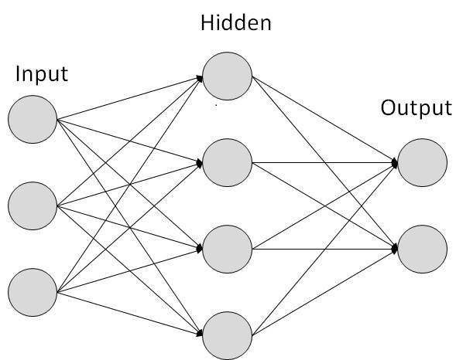

**MATHEMATICAL MODEL:**

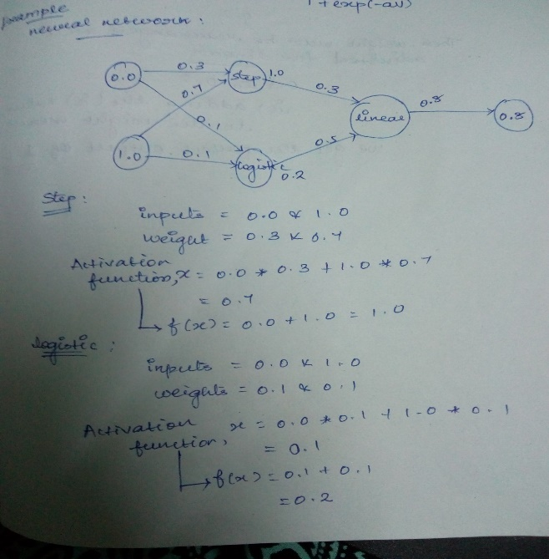

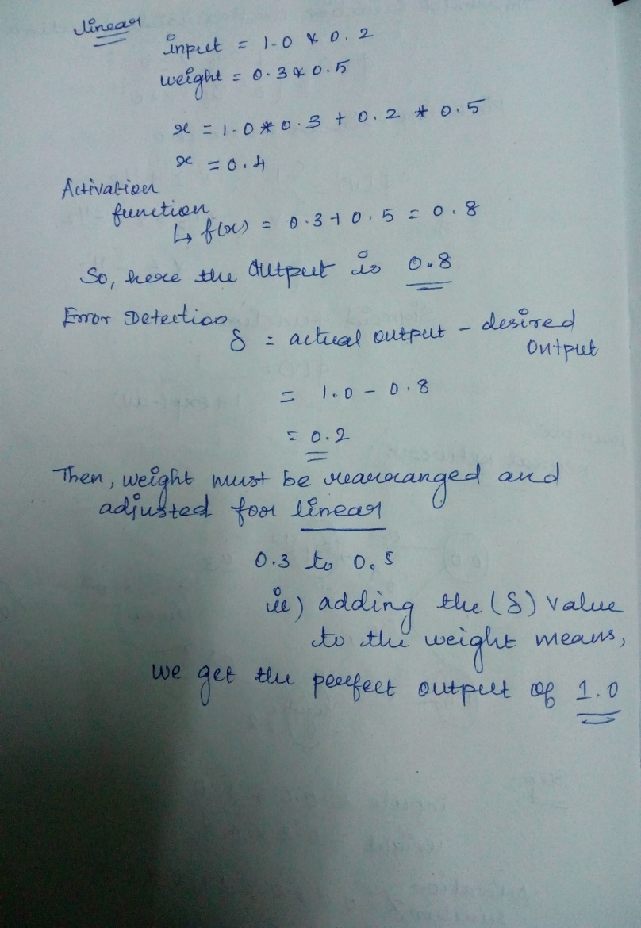

**USECASE OF ARTIFICIAL NEURAL NETWORK:**

* ANNs have the ability to learn and model non-linear and complex relationships, which is really important because in real-life, many of the relationships between inputs and outputs are non-linear as well as complex.
* ANNs can generalize — After learning from the initial inputs and their relationships, it can infer unseen relationships on unseen data as well, thus making the model generalize and predict on unseen data.
* This ANN is very useful in financial time series forecasting (e.g. stock prices) where data volatility is very high.

**PARTICLE SWARM OPTIMIZATION**

**DEFINITION:**

Kennedy and Eberhart first established a solution to the complex non-linear optimization problem by imitating the behavior of bird flocks. They generated the concept of function-optimization by means of a particle swarm.

The PSO technique is becoming very widespread because of its simplicity of execution position ore over capability to swiftly converge to suitable solution. As compared with other optimization techniques, it is cheaper, more efficient and faster.

**DECODE THE COMPLEX ALGORITHM:**

Particle Swarm Optimization technique, all particles are originated unsystematically and estimated to calculate suitability together with finding the best value of each particle and best value of particle in the entire swarm.

After that a loop starts to find an optimum solution. In the loop, first the particles’ velocity is updated by the personal and global bests, and then each particle’s positions are updated by the current velocity. The loop is ended with a stopping criterion predetermined in advance.

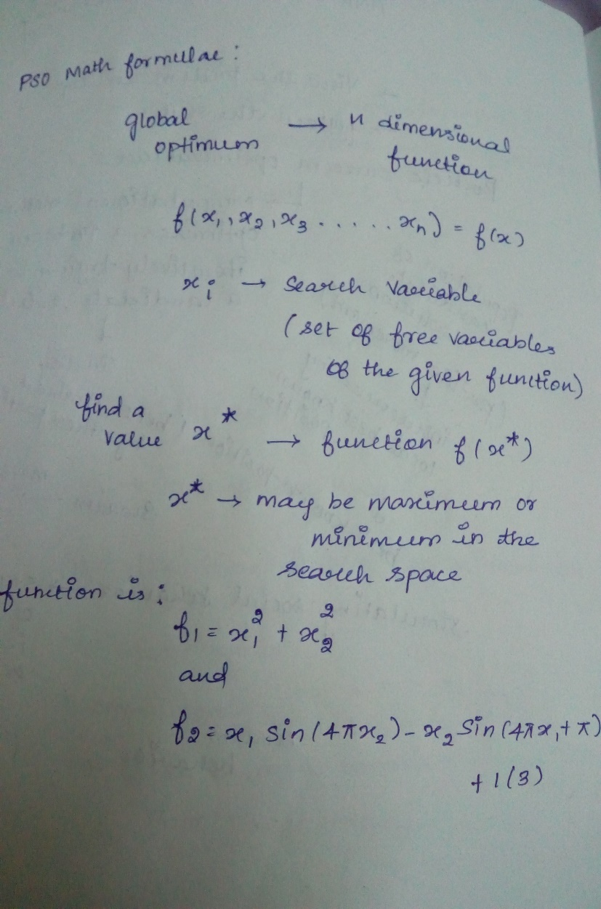

**USECASES OF PARTICLE SWARM OPTIMIZATION:**

* PSO algorithms avoid the problems normally associated with Gas in connection with ANNs.
* Using GA, crossover operator is not very likely to produce useful results from two different networks 🡪 avoid the destructive effects of crossover.
* In PSO there are no completely random mutations (velocity vector can be interpreted as “almost a gradient”).
* PSO have shown good performance in recent studies.